Linear – Cartesian planes and linear relationships



- A linear graph is a ___________________ graph that shows the relationship between two variables. It can be drawn if we know the rule (e.g. y= x + 2) that connects the two variables. This rule shows a linear _____________________.

- The ______________________________ is used to complete a table of values that shows the x and y coordinates of some points on the line. These are plotted on the _____________________________ and connected with a line.

- Any point on the line can be represented by coordinates, an x coordinate and a y coordinate. These coordinates are written as an ordered pair (______________)

- The ordered pair (____________) is known as the ________________.

Example
- Complete the following table of values for the rule y=x/2 +4 for the values of x in the range -2 to 2

x | -2 | -1 | 0 | 1 | 2
y
(x,y)

You try…
- Complete a table of values for the rule y= x + 1 for the values of x in the range -2 to 2.
- Graph once you have completed the table

x | -2 | -1 | 0 | 1 | 2
y
(x,y)

X and Y intercepts
- The _________________________________ of the graph is the point where the line crosses the _________ axis
- The _________________________________ of the graph is the point where the line crosses the _________ axis

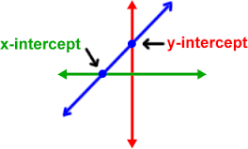

You Try…
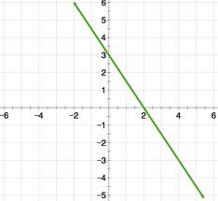
X intercept:

Y intercept:

Gradient
- The gradient tells us about the line of the slope.
- This line has a positive gradient as it slopes upwards from left to right

- This line has a negative gradient as it slopes downwards from left to right

- Line with the same gradient are parallel

You Try…
- (a) state the x intercept and write the coordinates of the point ________

- (b) state the y intercept and write the coordinates of the point ________

- (c) state whether the gradient of the line is positive or negative _________

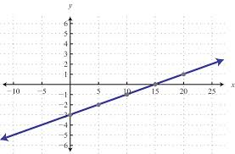

Special Gradients
Below is the table with the values for the equation y = 0x + 3 (or y=3)

x | 0 | 1 | 2 | 3 | 4
Y | 3 | 3 | 3 | 3 | 3

The equation produces a horizontal line (blue). It never crosses the ________________.
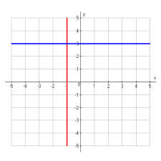
Below is the table with the values for the equation x = -1

x | -1 | -1 | -1 | -1 | -1
Y | 1 | 2 | 3 | 4 | 5

The equation produces a vertical line (red). It never crosses the ____________________.

A _______________________ has a gradient of zero

A _______________________ has a gradient that cannot be defined. We say the gradient is undefined

Example
Max has 10 litres of fuel left in his car’s petrol tank. When he fills it at the petrol station, petrol runs into the tank at 15 litres per minute. The petrol tank can hold 70L.

(a) identify the independent and dependent variables

(b) make a table of values for the number of litres of petrol in the tank after time t minutes and plot the graph of L against t

(c) is the relationship between L and t linear?

(d) is it sensible to going the points of the graph with a straight line?

(e) For every time increase of 1 minute, what is the change in L?

(f) Find the number of litres of petrol in the tank after 1.5 minutes

(g) At what time will there be 50L of petrol in the tank?

You Try…
Each week a department store employee receives a basic salary of $300. In addition, she is paid a bonus of $20 for each new member she signs up to the store’s rewards clubs. Let l be the employee’s income and m be the number of members she signed up to the rewards club.
(a) what are the independent and dependent variables?

(b) Construct a table and draw a graph of income I against members m where m = 0, 1, 2, 3, …, 10.

(c) is the relationship linear?

(d) is it sensible to join the points with a straight line?

(e) For each new member signed, what is the employee’s increase income?

